Instrumental Music Tuition

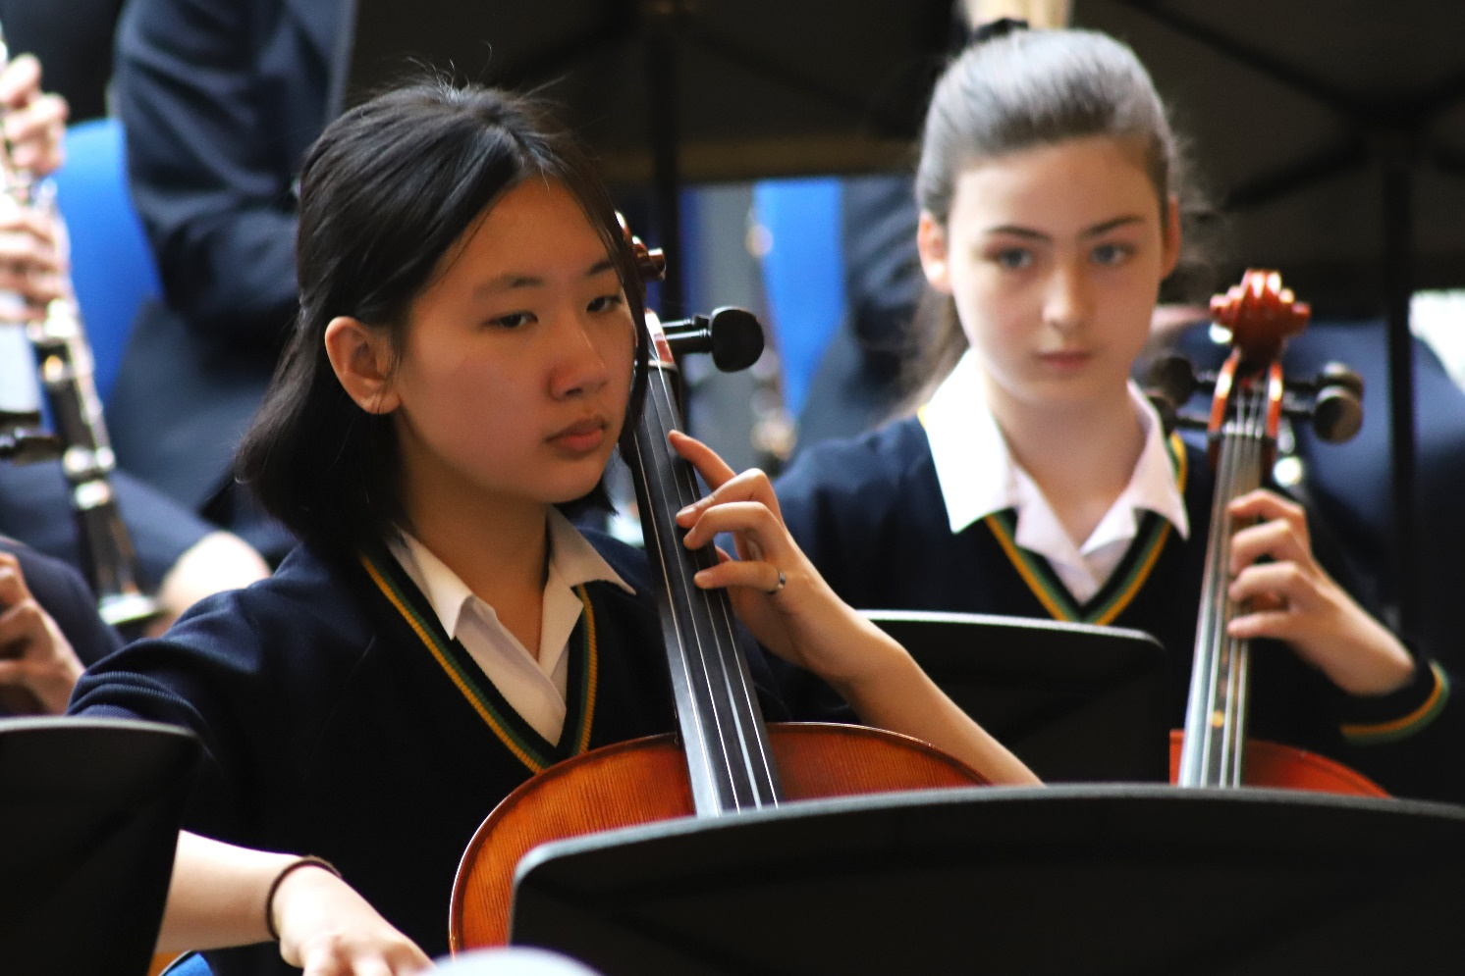

Why learn an instrument?

- It’s an excellent opportunity for your child to be taught a specific instrument by a specialist teacher. All our visiting music teachers play to a conservatoire level and have a wealth of teaching experience.
- Huge levels of confidence can be gained from performing in an ensemble/orchestra/band/choir.
- It’s great fun!

Which instrument should my child choose?

- An instrument they like the sound of – they need to be motivated to practise!
- What kind of music do they like? Choose an instrument that fits into an AGGS ensemble.
- Please attend the Music Induction Evening which will either take place at school on Monday 13th June– one parent/one child may attend. The evening runs from 6 – 8pm and there will be the chance for your child to try out the endangered instruments below. Ms Mayall will give a short talk about Music at AGGS.

‘Endangered Instruments’: Viola, cello, double bass, bassoon, french horn, trumpet, cornet, trombone, euphonium. Playing one these means easy access to orchestras/bands/ensembles, as they are in short supply!

And now for the instrumental details -

Instrumental tuition is given on:

Flute, oboe, clarinet, bassoon, trumpet, French horn, trombone, saxophone, violin, viola, cello, double bass, piano, acoustic guitar, voice and percussion (drum kit and orchestral percussion).

The instruments highlighted in bold above usually have the shortest waiting list.

There is always availability for lessons on: double bass, cello, viola, oboe, bassoon, trumpet, horn and trombone.

Theory Lessons

Theory lessons can also be arranged, particularly Grade 5 theory, which is currently needed to enter for Grade 6 or above in an instrumental exam.

Information about lessons offered; please read these carefully before replying:

either
- 30 minute paired lesson (with another pupil of a similar standard if the teacher recommends this) (£14) – not available on piano, percussion, double bass or cello
or
- 30 minute individual lesson (£19.00)

- The lessons will normally be given weekly in a series of 5 or 10 lessons. Accounts are sent for either 5 or 10 lessons by arrangement with the teacher, as our teachers are self-employed, and the fees are paid to the teacher before the beginning of each series.

- A half series’ notice, in writing, must be given to the teacher in order to terminate lessons, or fees for the following half series will be payable.

- It is not possible to stop lessons half way through a series.

-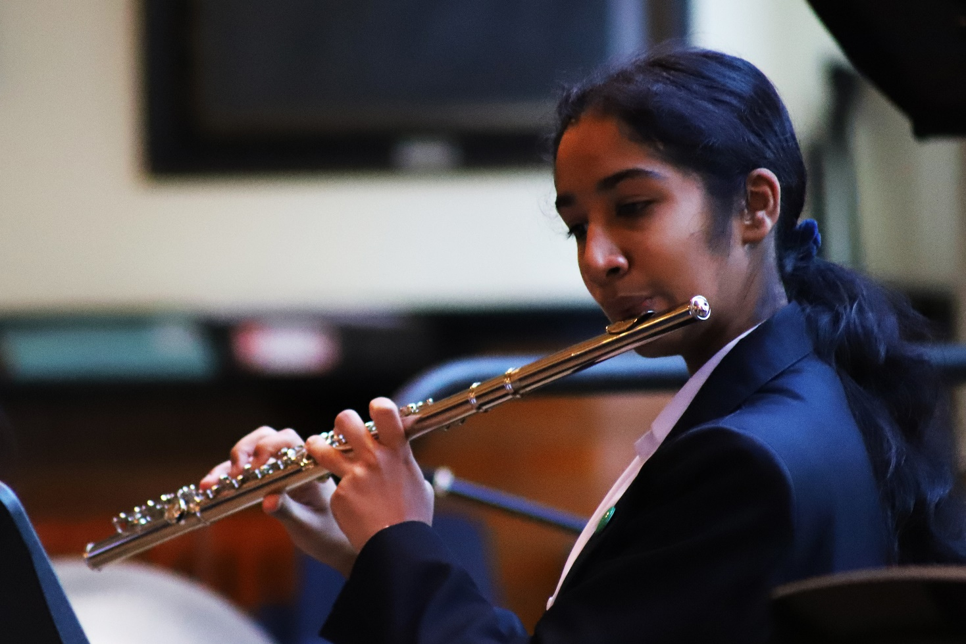

- For students in Yrs 7, 8 and 9, instrumental/voice lessons are timetabled throughout the school day. A rotating timetable operates, so that the same academic lesson is not missed each week. Students normally manage this well, so long as they are organised and use their planner in advance/watch the music noticeboard timetables to know when their instrumental lesson is each week.

It is not possible for students in Y7, 8 or 9 to have their instrumental lesson at lunchtime or before/after school, as these priority times are allocated to older students.

- Under normal circumstances, students may only take lessons on one instrument in school. Students who wish to learn additional instruments should organise lessons outside school hours.

- If the teacher is absent, the lesson will be made up during the term, or credited. Lessons missed through a student’s non-attendance will be charged for, unless the circumstances, in the teacher’s opinion, warrant a special concession.

Notice of a student’s absence should therefore be given by telephoning the teacher at home preferably the day before the lesson is due. The teacher should be given at least 48 hours’ notice of a student absence.

Insurance for Instruments and buying an instrument through school

- Some instruments can be hired from AGGS Music Department for an annual £55 charge: saxophone and viola. AGGS own a double bass in very good condition, which can be hired for free for one term to a committed new student.
- A student’s own instrument is not automatically insured when in school. It should be stored outside Room 11 using the storage area provided. You are strongly advised to take out ‘all risks’ insurance cover.
- Each instrument should be clearly named, both inside and outside the case, with contact details in case of loss. A coloured ribbon or small scarf should be attached to the case handle for further identification.
- Our teachers can advise about instrumental hire in general.
- As we are a state school, any instrument purchased through school to be used by a student can be bought without VAT. Please email sbrazewell@aggs.bright-futures.co.uk for further information.

Altrincham Grammar School for Girls
Music Department

Instrumental lesson fees (2022 - 2023)

One 30 minute lesson £19
One 30 minute paired lesson £14 each - not available on piano, percussion, cello, double bass

Parents are reminded that it is necessary to give teachers at least one half term’s notice/5 weeks’ notice in writing if lessons are to be discontinued. Failure to comply with this requirement will result in fees being charged until proper notice is received.

